***ADVANCED PHYSICAL DESIGN USING OPENLANE/SKY130***

Here is the complete report of the workshop using Google-SkyWater within the OpenLANE.

* **Table Contents:-**

1. SKY130 DAY1:-Inception of open-source EDA, OpenLANE and Sky130 PDK

* D1_SK1:-How to talk to computers?
* L1-Introduction to QFN-48 Package, chips, pads, core , die and IPs
* L2-Introduction to RISC-V
* L3-From Software Applications to Hardware
* D1_SK2-Soc design and OpenLANE
* L1-Introduction to all components of open-source digital asic design
* L2-Simplified RTL2GDS flow
* L3-Introduction to OpenLANE and Strive chipsets
* L4-Introduction to OpenLANE detailed ASIC design flow
* D1_SK3- Get familiar to open source EDA tools
* L1-OpenLANE Directory structure in detail
* L2- Design preparation step
* L3-Review files after design prep run synthesis
* L4-OpenLANE project Git link Description
* L5- Steps to characterize synthesis results

1. SKY130DAY2:-Good floorplan vs bad floorplan and introduction to library cells

* D2_SK1:-Chip floor planning considerations
* L1:-Utilization factor and aspect ratio
* L2:-Concept of pre placed cells
* L3:-De coupling capacitors
* L4:-Power planning
* L5:-Pin placement and logical cell placement blockage
* L6:-Steps to run floorplan using OpenLANE
* L7:-Review floorplan files and steps to view floorplan
* L8:-Review floorplan layout in Magic
* D2_SK2:-Library Binding and placement
* L1:-Netlist binding and initial place design
* L2:-Optimize placement using estimated wire length and capacitance
* L3:-Final placement optimization
* L4:-Need for libraries and characterization
* L5:-Congestion aware placement using RePlAce
* D2_SK3:-Cell design and characterization parameters
* L1:-Inputs for cell design flow
* L2:-Ciruit design step
* L3:-Layout design step
* L4:-Typical characterization flow
* D2_SK4:-General timing characterization parameters
* L1:-Timing threshold definitions
* L2:-Propagation delay and transition time

1. SKY130DAY3:-Design library cell using Magic Layout and ngspice characterization

* D3_SK1:-Labs for CMOS inverter ngspice simulations
* IO Placer Revision
* SPICE Simulation lab for CMOS Inverter
* Switching Thershold VM
* Static and dynamic simulation of CMOS inverter
* Lab steps to GitClone VSDSTD cell design
* D3_SK2:-Inception of layout A CMOS Fabrication process
* Create active Regions
* Formation Of N and P well
* Formation of Gate Terminal
* Lightly doped drain formation
* Source A drain Formation
* Local Interconnect Formation
* Higher level Metal Formation
* Lab Introduction to sky130 Basic layers layout and LEF using inverter
* Lab steps to Create STD cell layout and Extract SPICE Netlist
* D3_SK3:-SKY130 Tech File LABS
* Lab steps to create final SPICE deck using SKY130 tech
* Lab steps to characterize inverter using SKY130 Model files
* Lab introduction to SKY10 PDK’s And steps to download labs
* Lab introduction to Magic Tools options and DRC rules
* Lab exercise to fix poly.9 error in SKY130 Techfile
* Lab exercise to implement Poly-Resistor spacing to diff and Tap

1. SKY130 DAY4:-Pre layout Timing Analysis and importance of good clock tree

* Timing modeling using delay tables
* Timing Analysis with ideal clocks using Open STA
* Clock tree synthesis Triton CTS and signal integrity
* Timing analysis with Real clocks using Open STA

1. SKY130 DAY5:-Final Steps for RTL2GDS using TritonRoute and OpenSTA

* Routing and design check(DRC)
* Power Distribution network and routing
* Triton Route features

**1.SKY130 DAY1:-**

HOW TO TALK TO COMPUTERS:-

*INTRO TO QFN-48 ,PACKAGE ,CHIPS ,ETC;-*

It is an extensively used circuit board that is ARDUINO. Which can be seen in the figure below

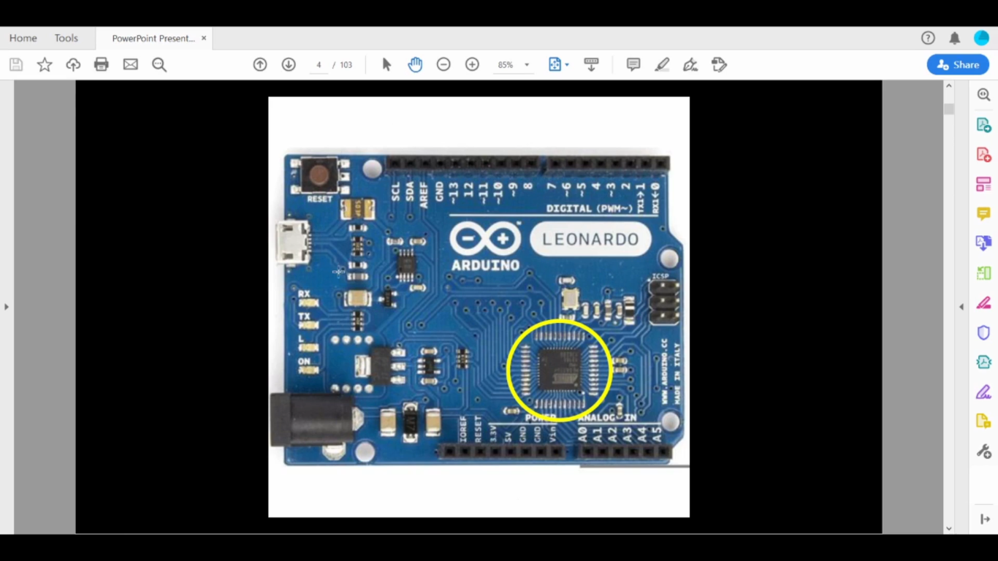It is a processor i.e system on Chip. The main part in chip rounded with yellow colour

The yellow region can been seen through some diagram known as BLOCK DIAGRAM show in below

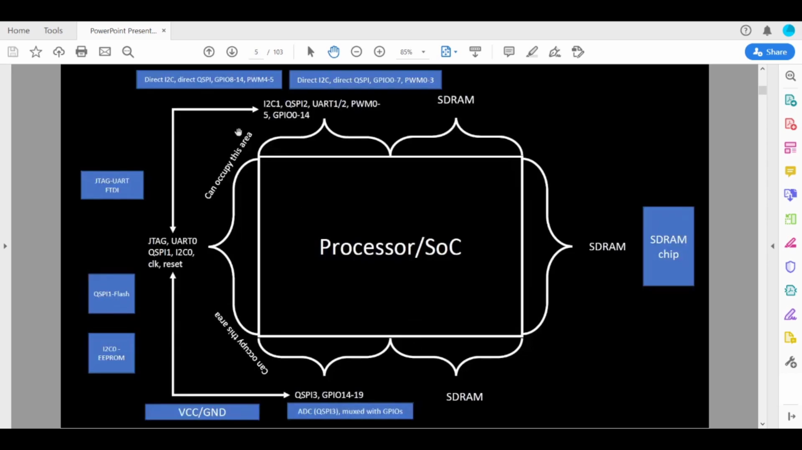

From the picture we can some big boxes which are known as SoC . From the layman’s terms it is mainly called as CHIP. Termed as PACKAGE, which is mainly used arduino board

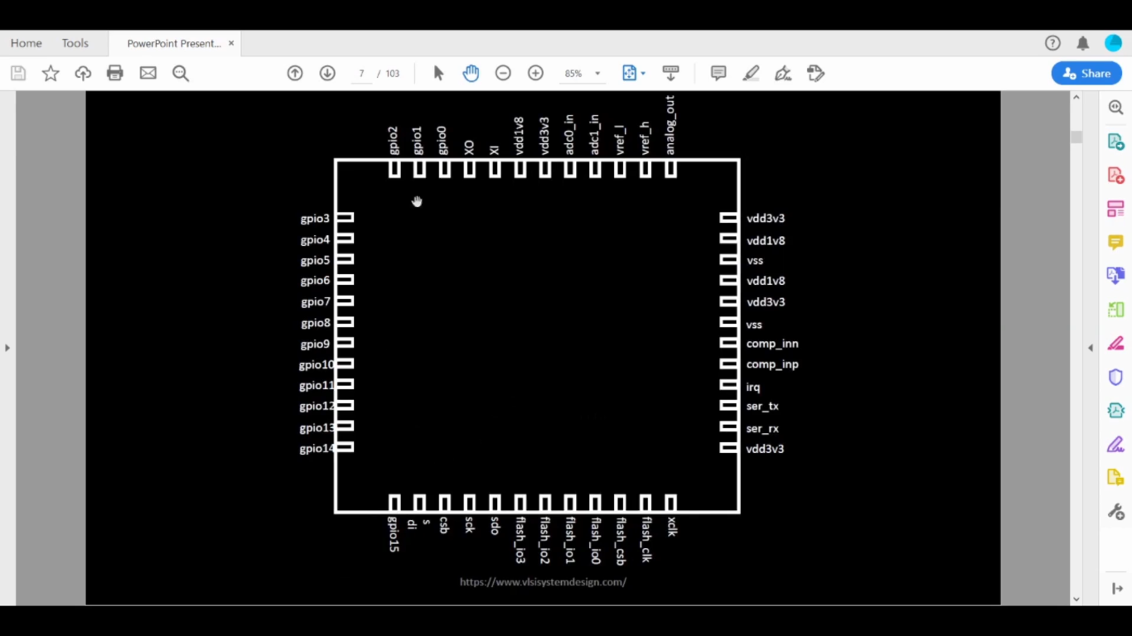 PACKAGES can be represented mainly from the above figure:-

As observed chip is an inside package which is connected mainly to various PINS or may be also known inputs/outputs.

A chip has some various existing components as following:-

* PADS:-They are connecters between circuit and chips
* CORE:-This is the digital logic with some gates in that such as AND, NOR .
* DIE:- It is a part of semiconductor wafer that can be used in devices.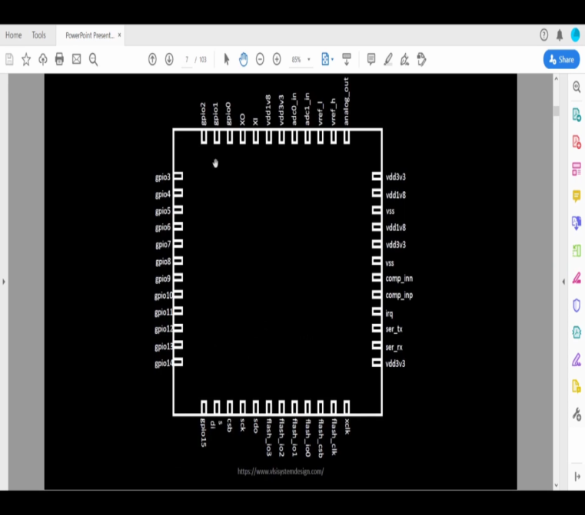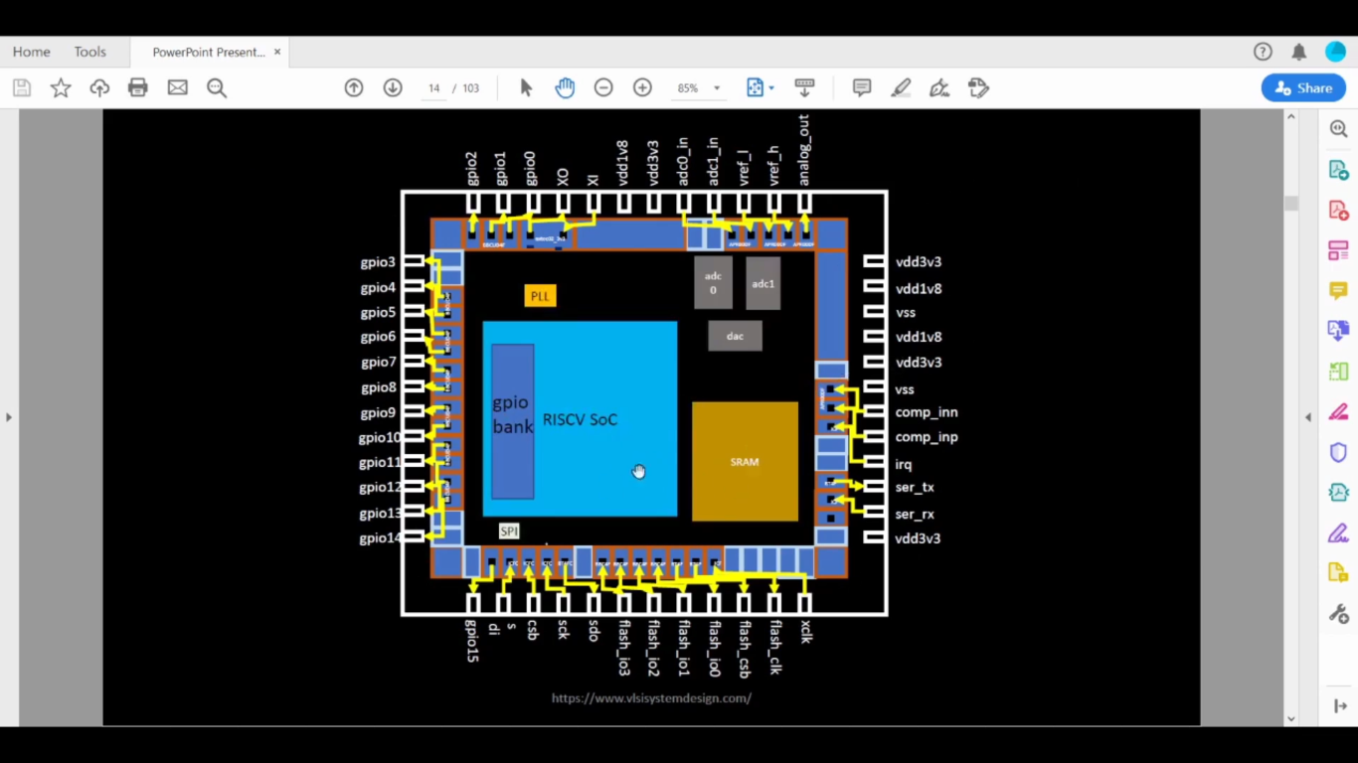

This is schematics of RISC with some various components in that such as FOUNDARY IPs, MACROs.

*INTRODUCTION TO RISC V:-*

The full form of RISC V is Instruction set Architecture which is the language in computer. If C program must be runned than this RISC V is complied.

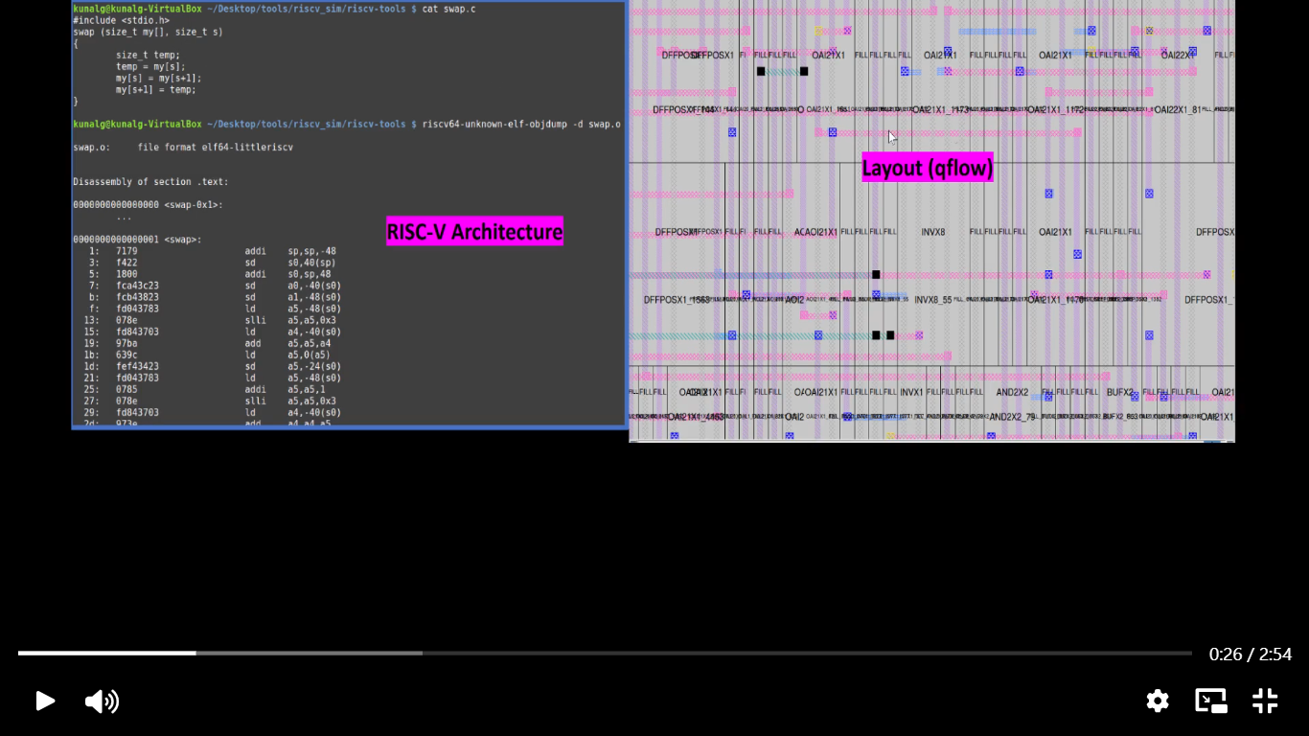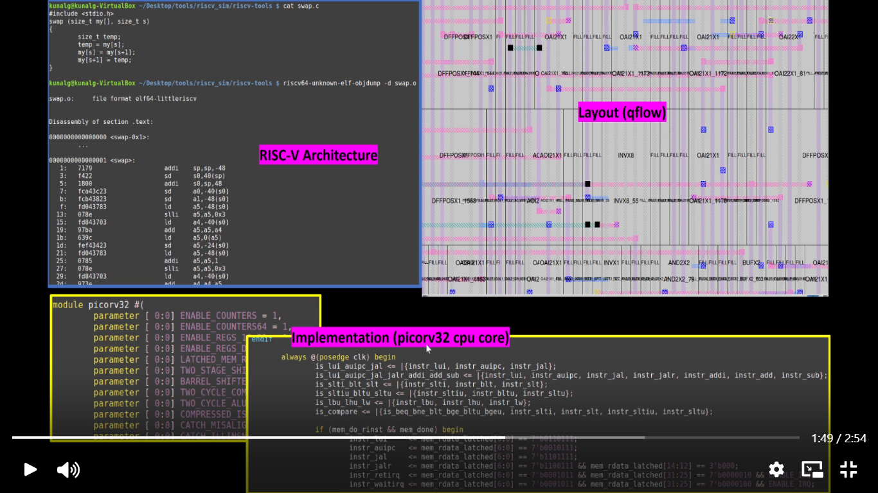

*FROM SOFTWARE APPLICATIONS TO HARDWARE:-*

*It is also known as APPS. They basically run on hardware such as laptops, phones, etc.*

*This is by system software that is majorly:-*

* *Operating system*
* *Compilers*
* *Assemblers*

